SEO SWOT analysis: How to optimize where it counts

<https://searchengineland.com/seo-swot-analysis-focusing-efforts-improve-results-287197#:~:text=The%20SEO%20SWOT%20can%20be,threats%2C%20typically%20from%20external%20sources>.

SWOT: Strengths, weaknesses, opportunities and threats

A SWOT analysis is a strategic planning tool that identifies:

* **S**trengths.
* **W**eaknesses.
* **O**pportunities.
* **T**hreats.

The SWOT is a tool to perform a situational analysis for each key area.

* **Strengths:** Areas in which you are strong and that give you an advantage over the competition and which should be capitalized on.
* **Weaknesses:** Areas where you are at a disadvantage relative to your competitors and should be addressed.
* **Opportunities:** Areas where there is potential for growth and that can be exploited to your advantage.
* **Threats:** The threats that are in the environment that could cause trouble for your business now and in the future.

The purpose of a SWOT analysis is to arm you with intelligence concerning your market position and to guide you to exploit opportunities with strengths while addressing weaknesses and threats. Attack and defend.

The SEO SWOT can be presented in a simple grid system that has four panels that cover helpful, harmful, internal and external factors.

o give you a starting point here, consider the following areas:

### **SEO strengths**

These are areas where you excel, so reviewing your analytics, rank-tracking software, and Google Search Console is a sensible first step.

You can also review the technical, on-page and off-page optimization of your site.

* Organic traffic
* High-performing keywords
* High-performing pages
* Domain authority
* [Content quality](https://searchengineland.com/what-is-quality-content-251071)
* On-page optimization
* [Backlink profile](https://searchengineland.com/backlink-profile-audit-385392)
* [User experience](https://searchengineland.com/analyze-ux-metrics-improve-seo-385559) (UX)
* [Site speed](https://searchengineland.com/speed-page-experience-seo-387478)

### **SEO weaknesses**

These are areas where you are weaker and potentially disadvantageous to your competitors. Reviewing your visibility metrics relevant to your optimization is the path forward here.

* No keyword strategy
* Low visibility in local listings
* Low visibility in organic listings
* Poor mobile experience
* Slow load times
* Inadequate technical SEO
* Low-quality backlinks
* Historical penalties or low-quality SEO
* Low-quality content

### **SEO opportunities**

These are areas of potential growth for your business. Reviewing your weaknesses, keyword strategy, and the SERPs, along with keeping up with search news, are all ways to identify where opportunities may lie.

* Improving weak areas
* New areas within your industry
* Relevant keywords you are ranking poorly for
* New emerging keywords in your industry
* Long-tail search keywords
* Content opportunities
* New SERP features
* Relevant sites in your field where you could guest post
* New technical SEO opportunities (AI, schema, etc.)

### **SEO threats**

By being mindful of threats, you can avoid potential problems and keep pushing for visibility in a rapidly shifting search landscape.

* [Algorithm updates](https://searchengineland.com/library/platforms/google/google-algorithm-updates) and changes
* New competitors entering the market
* Existing competitors improving their SEO
* Fluctuations in search volume (school holidays can be low)
* Not keeping up to date with what Google is aiming at (e.g., [E-E-A-T](https://searchengineland.com/google-e-e-a-t-guide-seo-394191))
* Technical website issues
* Security Issues (website hacking, comment spam)

<https://searchengineland.com/a-basic-seo-audit-for-small-businesses-305896>

The Screaming Frog SEO Spider is a website crawler that helps you improve onsite SEO by auditing for common SEO issues

<https://www.screamingfrog.co.uk/seo-spider/>

google Lighthouse

<https://www.searchenginejournal.com/core-web-vitals/google-lighthouse/>

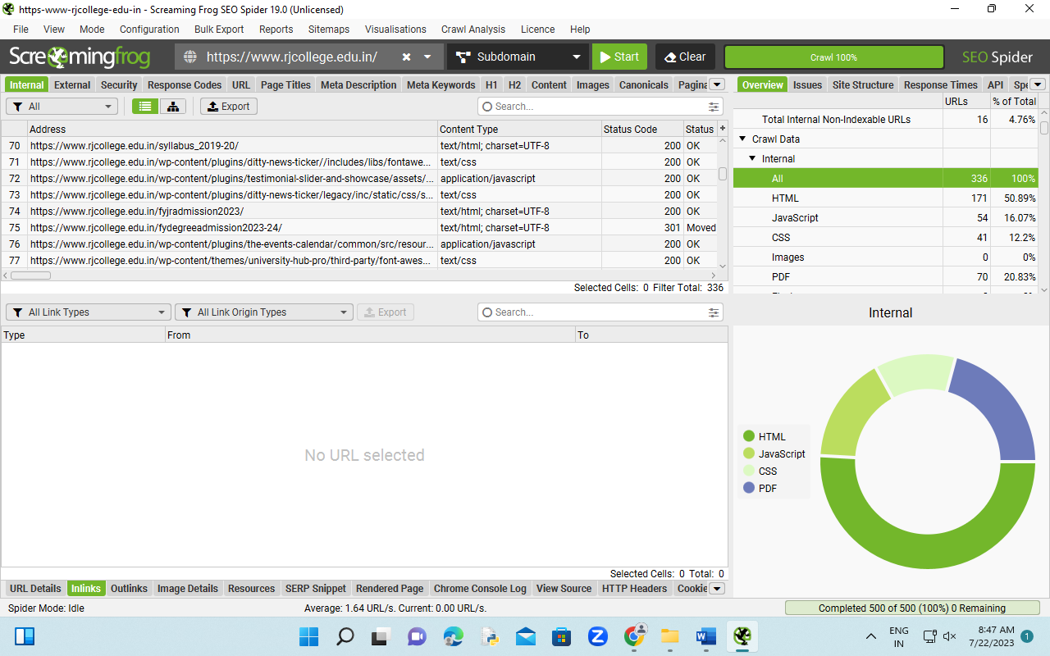

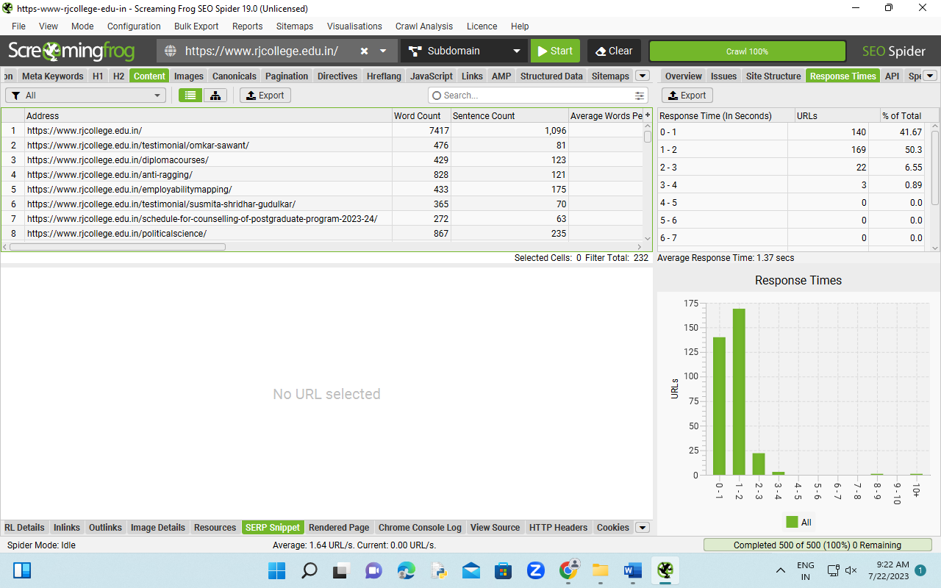

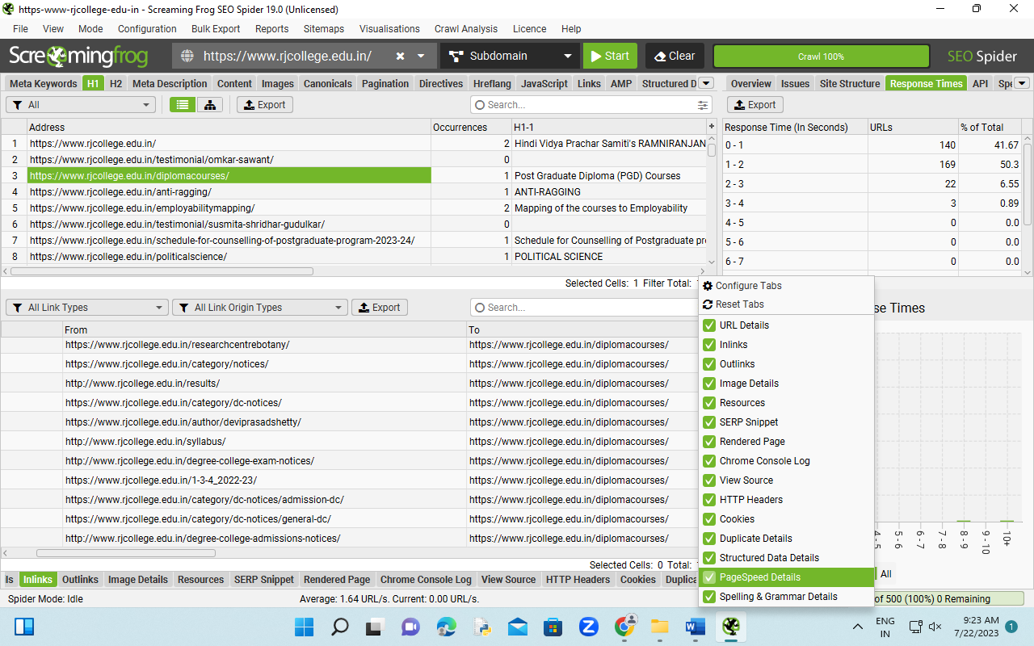

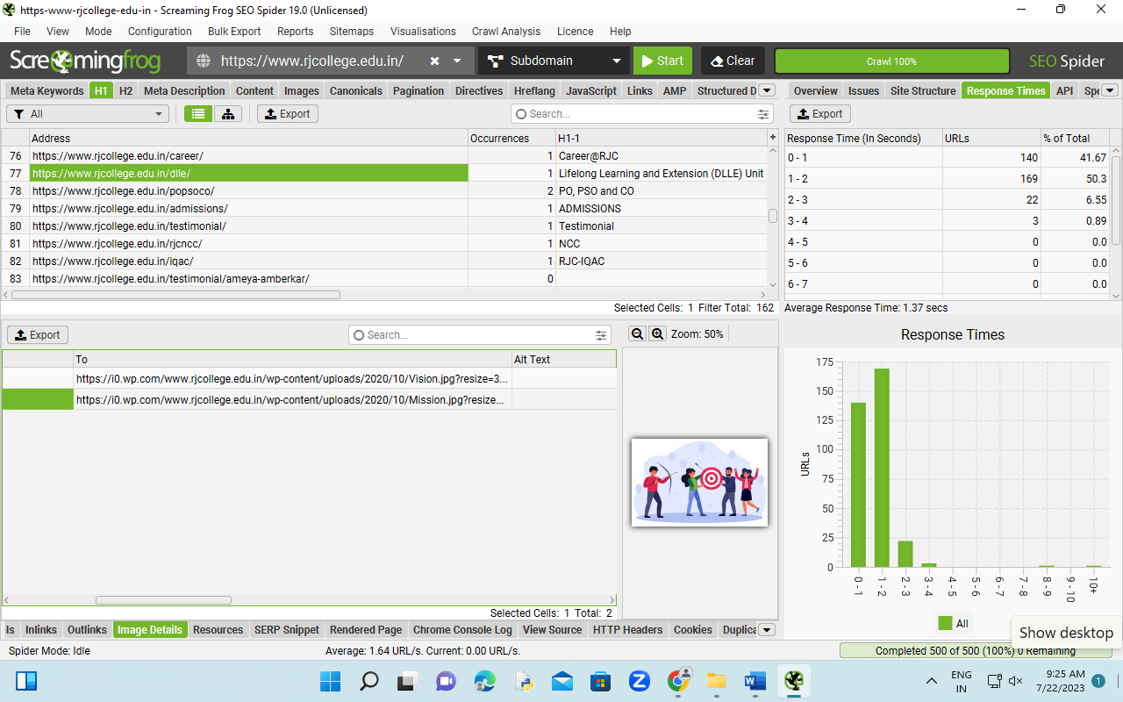

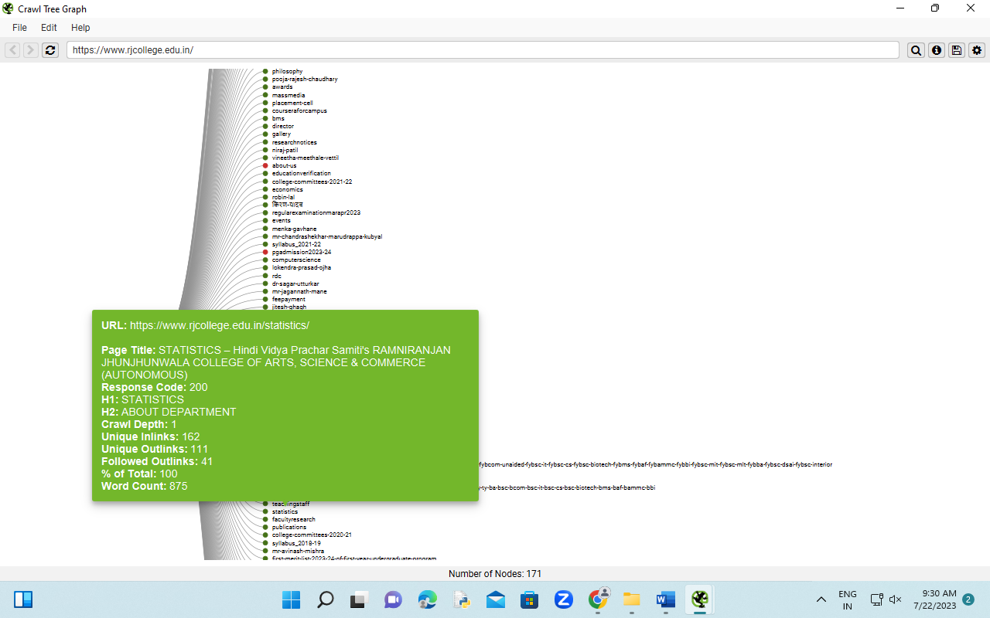

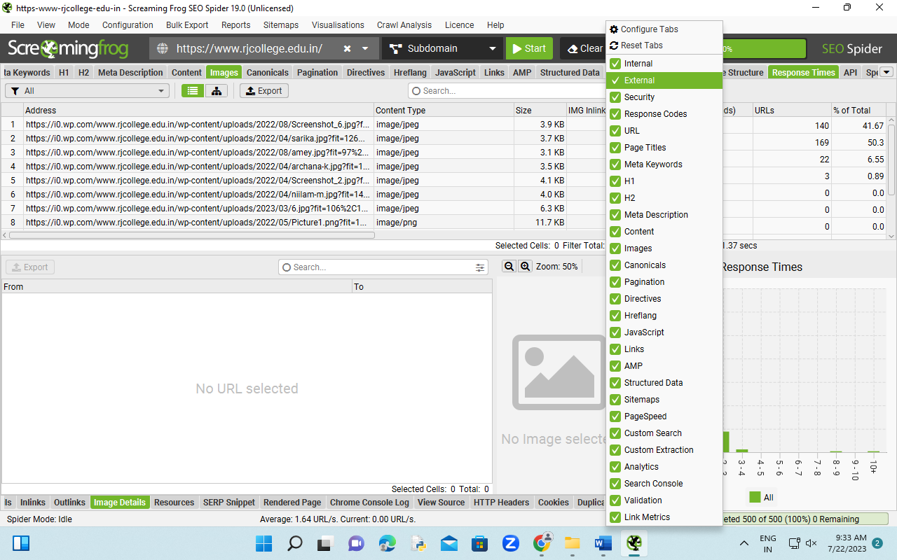

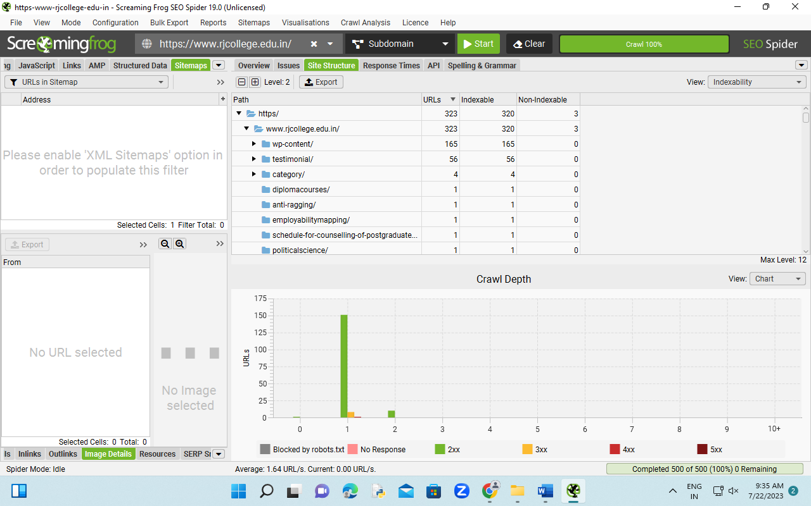

## What are SEO goals?

SEO goals aim to progress your SEO and support your broader marketing and business objectives. Typically, you will target awareness and engagement with prospective customers on search engines.

When looking to improve your SEO, you will look at rankings, impressions, click-through rates, clicks and the subsequent engagement of that traffic. You may also consider aspects such as the size of an opportunity (keyword volume and impressions).

Creating practical goals is the first step in crafting an SEO strategy, and should consider the following five steps:

* **S**pecificity: The goal must be clearly defined so it can be measured.
* **M**easurable: Goals must be quantifiable so you can track progress.
* **A**chievable: Goals should be realistic within your resources.
* **R**elevant: Goals should map to higher-order business and marketing goals.
* **T**ime-bound: Goals must consider time to aid the measurement.

Fortunately, this being marketing, there is a handy mnemonic to help us remember these critical factors in practical SEO goal setting: SMART goals.

## SMART goals for SEO

The SMART goals framework is not new. It is widely used in project management, personal development and psychology.

I believe in using time-proven marketing concepts within our SEO work. Often, intersecting your SEO skills with these battle-tested marketing concepts can really drive performance.

We have seen in our agency that using SMART goals for SEO is a smart move.

Let’s look at how the stages break down and examples of how you can create your own SMART SEO goals.

### **S: Specific**

Specificity is the first step toward creating actionable SEO goals.

As an example, better rankings are not a specific goal. Ranking in the top 3 results for keyword X nationally is a specific goal.

A broader yet specific goal could also be improving organic traffic by 25%, but as you become less specific, you must also apply some critical thinking about how you will achieve this and state this in your goal.

Questions to ask yourself or your team include:

* What are we trying to achieve?
* How does this help us achieve our marketing goals?
* What do we need to do to achieve this?

Then you make this goal more specific:

* “Improve organic traffic by 25% by improving the rankings for all our commercial keywords on our category pages. “

It is also useful to ensure you build your specific goal on top of clearly defined business and marketing goals. This provides a hierarchical set of goals so you can question whether this SEO goal helps you achieve your marketing goals.

Your goals should be crystal-clear and connected to our business objectives so that everyone from the boardroom to the marketing department understands what success looks like.

### **M: Measurable**

To understand if you are making progress towards a goal and if that goal is truly helping you achieve the underlying goals, we must make the goal measurable.

Fortunately, with SEO, we have plenty of touchpoints we can use to track success.

There are many SEO KPIs, and the right measurement metrics depend upon your goals, but the following should help get you started.

**SEO metrics**

* Rank for main converting keywords (local/organic).
* Rank for secondary benchmark keywords (local/organic).
* Organic clicks (Search Console).
* Organic impressions (Search Console).
* Organic CTR (Search Console).
* Organic average position (Search Console).
* Trust and citation balance.

**Link building metrics**

* Total links built.
* Number of links from authority sites.
* Number of links from relevant sites.
* SEO Tool Domain and Page Metrics.

**Real-world metrics**

* Increase in organic traffic.
* Increase in the number of pages on the site that generate traffic.
* Increase in non-branded search traffic.
* Percentage increase in organic conversions.
* Organic Impressions (Search Console).

Just remember to identify metrics that will help you track progress and not just the end goal so you can identify if your tactics are working!

### **A: Achievable**

When it comes to SEO, how realistic and attainable your goal is requires some soul-searching and hard truths.

We don’t want to aim too low; goals should be aggressive. However, we must ensure that our goals are realistic within your resources (money, manpower etc) and a sometimes harsh search reality.

A helpful job here is to search for your keywords and pay close attention to the search results. What do you see? Who is ranking? What types of results are there? Where are the opportunities? What could you do better?

When it comes to deciding what is achievable, this is not always easy in itself. We could look at typical SEO metrics from third-party tools, and that has its place, but I would suggest a more nuanced and qualitative approach. Consider competitor SEO metrics, but focus on what you could do better.

If your look at “what is achievable” through the lens of “what could you do better” then your SEO strategy is quality driven rather than metric driven.

This enables you to set more exciting goals and works more with what Google is looking for (to deliver the best possible results).

Key areas to consider here are:

* **Quality**: What can you do better?
* **SEO feasibility**: Are you in the same league as the page 1 results?
* **Situation**: Are you in the same league as the big players on the first page?
* **Resources**: Do you have the resources to hit these goals?

Sometimes you won’t progress as you had hoped. This is inevitable, and it is just as important, possibly more so, to understand when you are not making progress so you can adjust your strategy accordingly.

Ultimately, the best SEO goals are never born fully formed; they grow and develop over time as you target them and evolve your approach.

### **R: Relevant**

It is very easy to end up chasing the wrong goals.

There are two ways to ensure an SEO goal is truly relevant:

* Explain how this SEO goal helps you achieve your overall marketing goals.
* Cross-reference this with conversion data from paid search.

You are looking to come at this from a common sense perspective to explain the theory and then back that up with data where possible.

By proving from two directions, you help ensure this is a truly relevant goal that will help drive your marketing forward.

You want to end up with a statement along the lines of:

* “We want to rank for [x] to improve our visibility and traffic from customers searching for a [x]. This will help us generate more local awareness and drive more enquiries and sales. Paid search data shows us this keyword has a 10% conversion rate so we know this traffic is highly valuable and will drive leads and sales.”

Ultimately, with relevance, you are just quickly checking in that this is a sensible use of your resources and connects to the overall mission.

### **T: Time-bound**

All goals need to have a target date to achieve. If you don’t have that deadline, then you don’t know when to give up or assess progress.

SEO is different from most marketing tactics as it can take longer to achieve. Therefore, we may not see any actual hard results (sales or leads).

So, introducing time-bound goals for SEO, along with milestones showing progress, is essential to know you are not chasing rainbows and things are moving in the right direction.

Determining how long how long SEO will take is not easy, so rather than striving for perfection, do your best and then review as you make progress.